|  |  |  |
| --- | --- | --- |
| **C++ Programming** | **Student**  **number** | **21300691** |
| **Homework 4** | **Name** | **Cheung, Won Sik** |

Structures

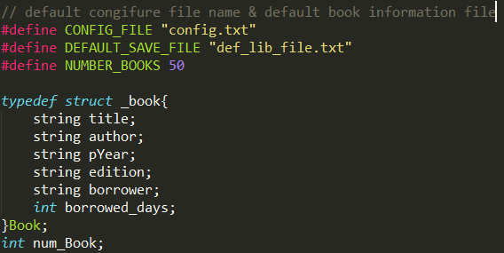

Main Function

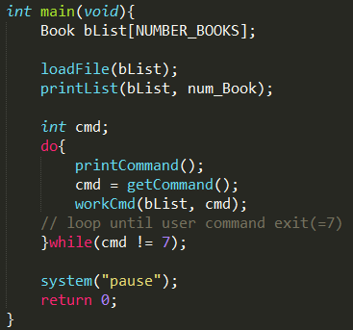

Load File Function

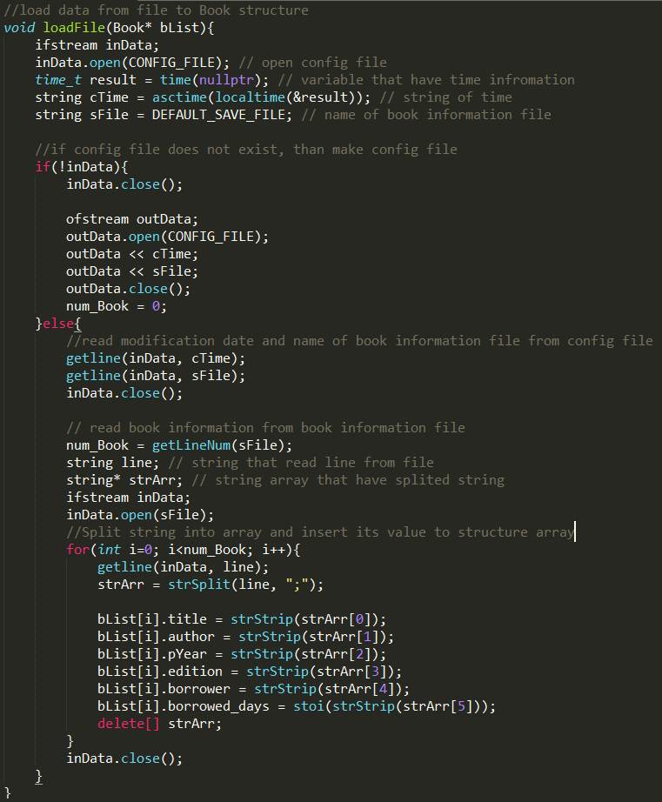

Print Book List Function

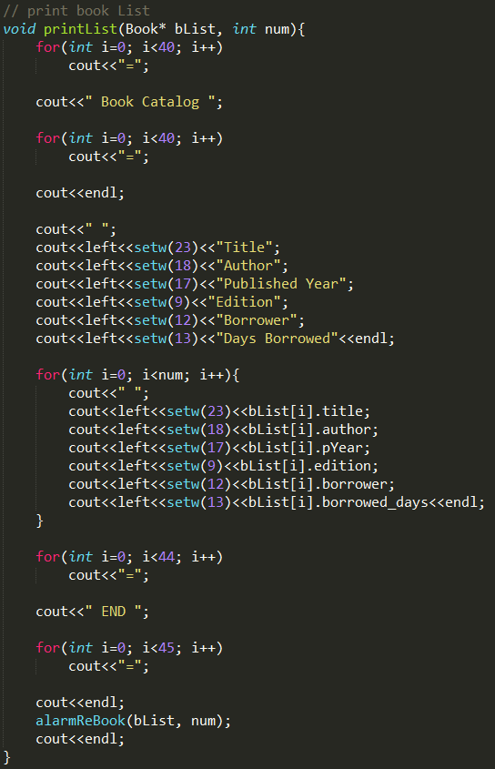

Print Command Function

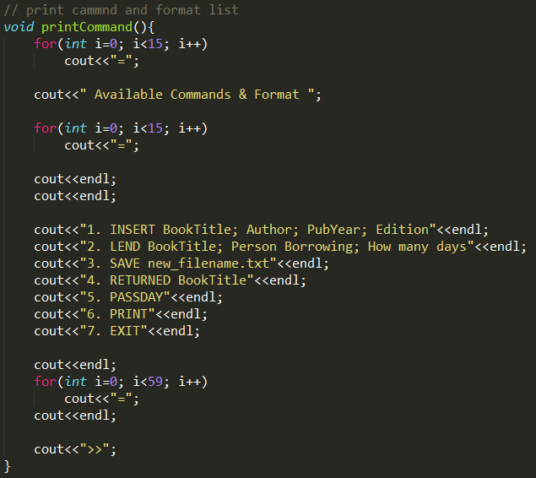

Parse Command Function

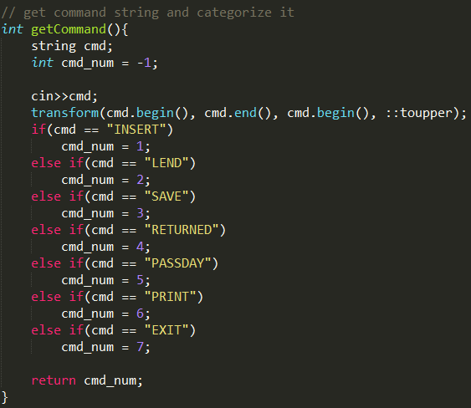

Function that Execute Other Function by Command

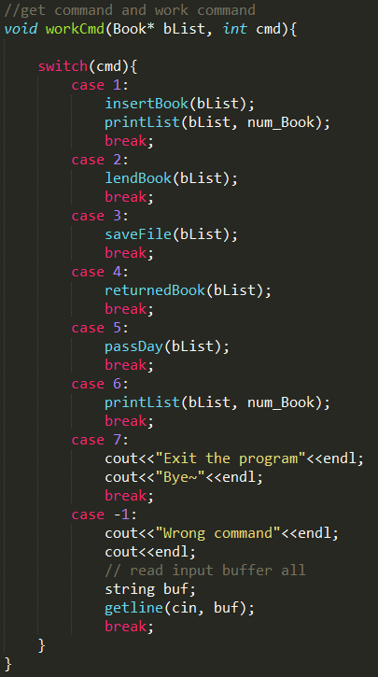

Insert Book Function

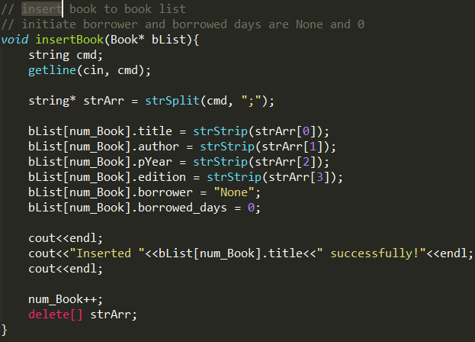

Lend Book Function

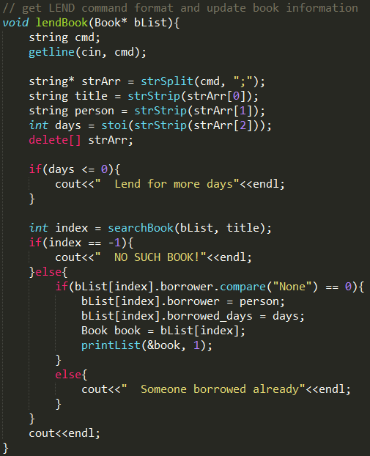

Save File Function

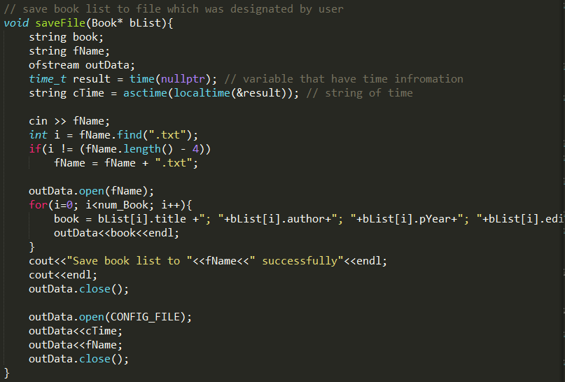

Returned Book Function

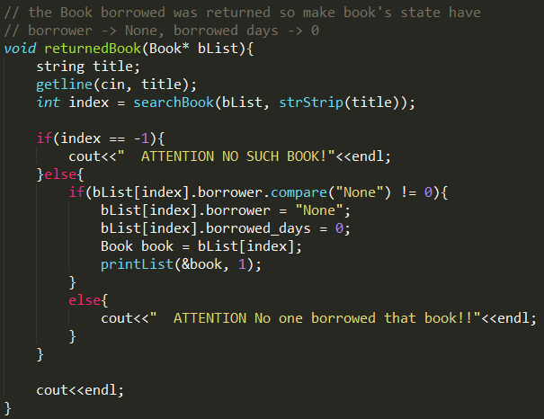

Pass Day Function

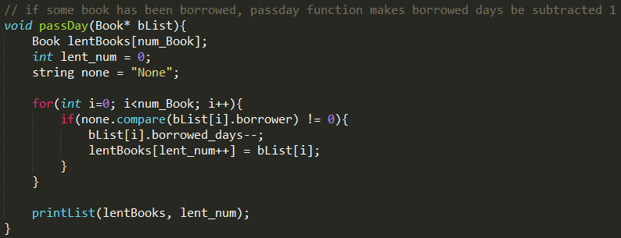

Result

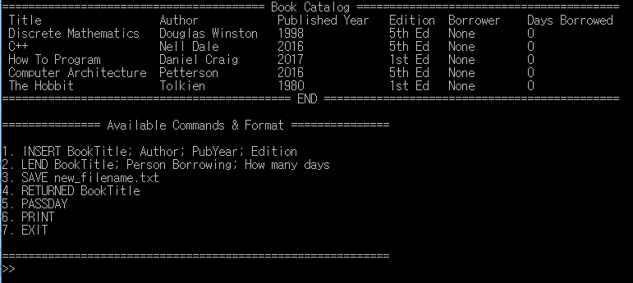

Insert

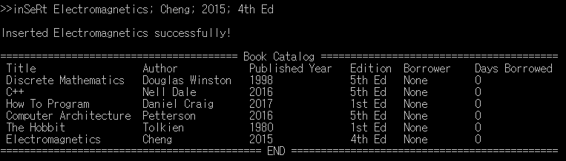

Lend – Normal Situation

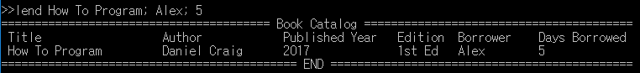

Lend – Lend Already Borrowed



Lend – No Such Book



Returned – Normal Situation

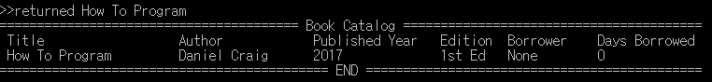

Returned – No One Borrowed



Returned – No Such Book



Print

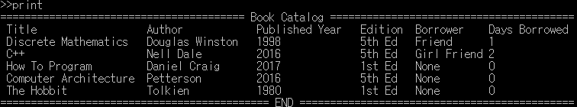

Pass Day

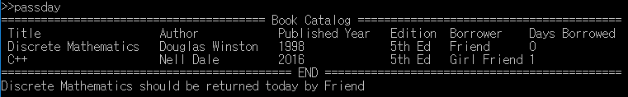

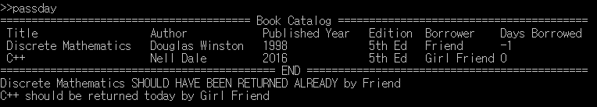

Save

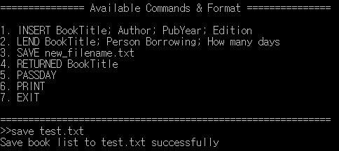

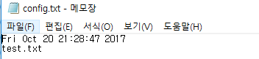

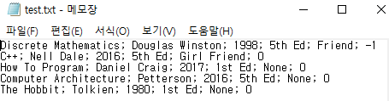

Exit

